Note that this document provides the questions for the Hello Cincy: Executive application. To be complete, you must submit the application online. This document lets you see what is on the application while providing you with time to think about and write out the answers to the open ended long questions. You must submit this online through the online application.

Warning: If you want to exit and come back to a started (but not completed) application, you MUST hit pause. Exiting does not save your application.

Application Questions:
Admission is competitive and space is limited. Please submit your application online as soon as possible for the best opportunity to be accepted. If you need to step away from your application and finish it at a later date, you will be able to do so.

To complete your application, you will need to
- Complete the online application by February 10, 2026. The online application includes open-ended questions. We recommend downloading this document with the questions, taking time to think about and answer them, and saving them on the document. Then copy and paste into the online application when ready.
- There will be a non-refundable $50 application fee due at the time of submission. Once you hit the submit button, you will be automatically redirected to make your payment. Your application will not be considered complete or reviewed until we receive this payment. If you have any issues submitting your application or processing your payment, please contact Emily Croft at ecroft@cincinnatichamber.com.

To begin, you must have a Chamber portal login. If you have attended a Chamber event last year, you should have one. If you need to create one, you can do so here: https://portal.cincinnatichamber.com/s/new-registration?startURL=%2Fs%2F

Link to start application:
Hello Cincy: Executive: https://portal.cincinnatichamber.com/s/hello-cincy-executive-application

Application Questions:
Your Basic Information
- Name
- Job Title
- Company/Organization
- Work Email Address
- Personal Email Address
- Preferred Email Address (throughout program)
- Work Phone Number
- Personal Phone Number
- Your LinkedIn URL
- Do you have any dietary restrictions? If so, what are they?
- Do you need any special accommodations to participate in this program (this is only asked to ensure we design the experience in a way that is accessible to all)?
- Home/Personal Address
- Company Address
- Country of Origin
- Date of Birth
- Race/Ethnicity
- Gender
- Are you a Veteran?
- Sexual Orientation
- What are your pronouns?

Background & Career History
- What is the nature of your business/organization?
- How long have you lived in the Cincinnati region?
- Where did you live prior to moving to the Cincinnati region?
- Have you previously applied to or participated in a Cincinnati Regional Chamber or other community leadership program (e.g., Leadership Cincinnati, C-Change, WE Lead, Urban Leaders Program, Leadership Northern Kentucky)?
- Please list names of any additional organizations with whom you work or volunteer.
- Please list membership, leadership roles, and/or awards in school, community, civic, professional, religious, and social organizations that have been of significance to you.
- Will your spouse participate? (+ $750 to tuition costs)

Program Commitments
- Have you spoken to your leadership to confirm their support prior to completing this application?
- Do you have full support from your employer for the required time away from work to participate in the program?
- Is your company/organization sponsoring your tuition?
- I understand the purpose of Hello Cincy Executive and the time and energy necessary to make it a successful experience if I am selected to be a participant.
- I understand the attendance requirements and have blocked my calendar now to make this a priority.
  - If you already have a schedule conflict for one of the sessions, please tell us which one & why.
- How did you hear about Hello Cincy: Executive?
- Partial grants may be available for small non-profits, entrepreneurs, or those self-paying base on need. Would you like to apply for grant money?
  - Partial grants may be available for small non-profits, entrepreneurs, or those self-paying base on need. Would you like to apply for grant money?
  - Enter grant amount requested:
  - Please briefly explain why you are requesting financial assistance and how you think your participation in the program would provide a distinct and positive addition to the class.
  - If you do not receive the grant requested, will you still be able to take part in the program if accepted?

Open Ended Questions
- Why are you interested in participating in this program? What do you hope to gain from the experience? (100 words or less)
- Why is now the right time for you to participate in this program? (100 words or less)
- What are your goals for this program?
- Please share with us something else, not mentioned in this application, that will help us get to know you better as an individual. This can be personal or professional, serious, or fun.
- Please type your biographical sketch below. Bios should be limited to 100 words. A sample sketch is noted in the prompt above the answer box. This information, along with your headshot, will be published in a directory to all participants.
- Upload Headshot
- Signature
- Pay Application Fee

3/25/2026
4/13/2026
4/27/2026
5/18/2026
6/1/2026
6/22/2026
Questions? For Hello Cincy: Executive, email Emily Croft at ecroft@cincinnatichamber.com.

Pausing & Resuming Application
- You may pause your application by clicking the “Pause” button in the bottom left of the questionnaire page.
  - You will be allowed to pause even if you receive notifications that the “required field must be complete.”
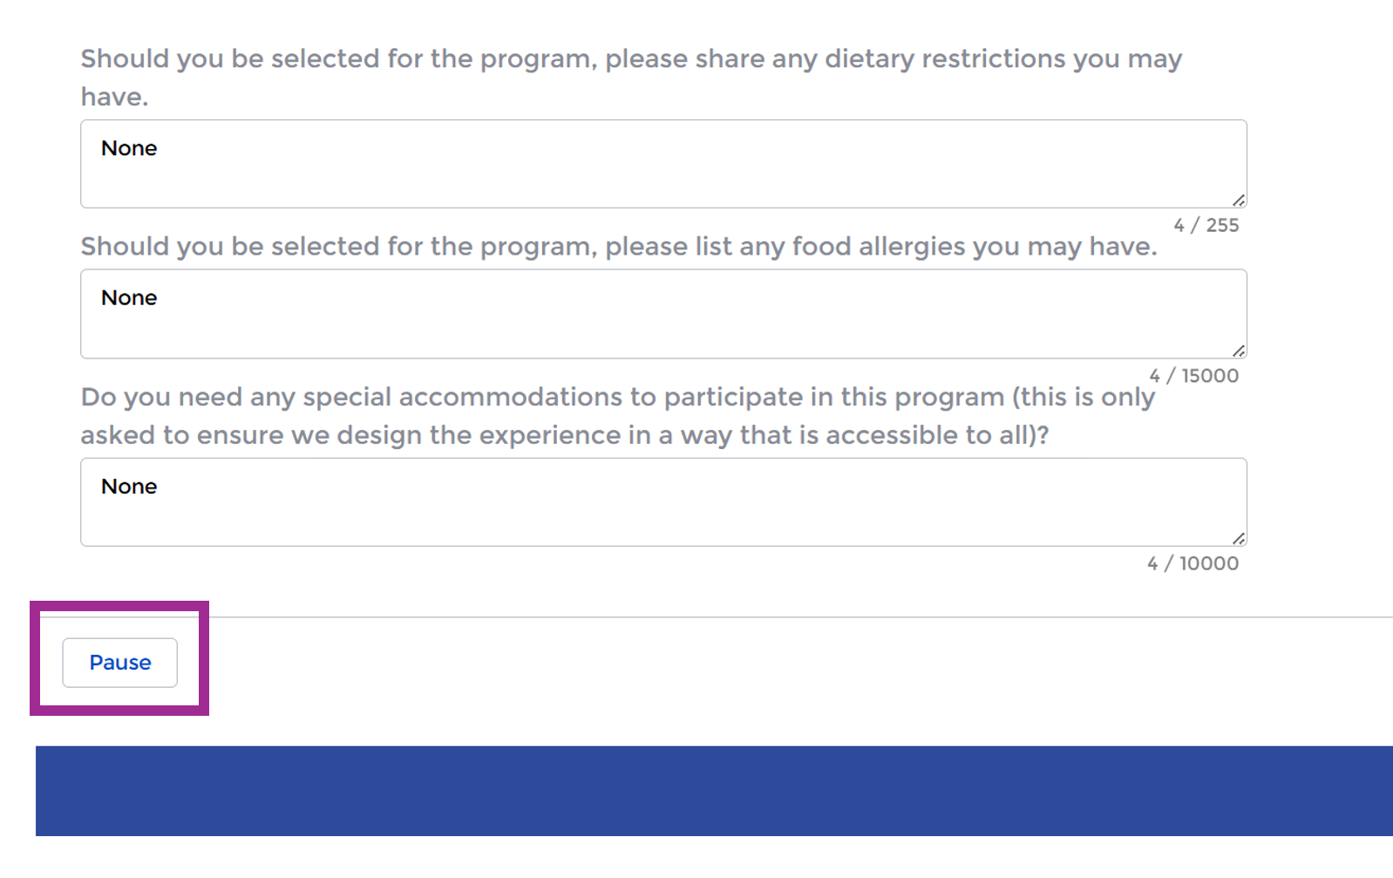

- To resume your application login to your portal profile page: https://portal.cincinnatichamber.com/s/#/profile/my_info/
  - Select “Application(s) in Progress” tab in the vertical navigation menu.
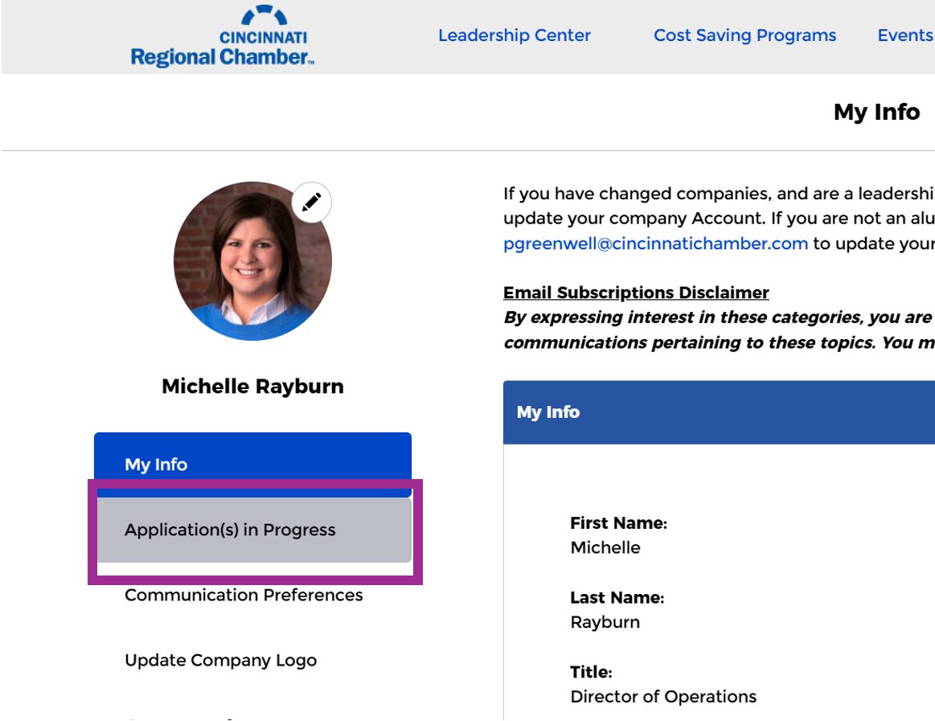

- Click the “Resume” button on the Paused Flows page to continue your application.
***IMPORTANT: You must complete the page you resumed and click to the next screen in order to pause your application again. If you pause your application on the same page you resume, it will be deleted by default.

